Ramp-up: How to Start Dev Marvell Android
APSE-PIE-Android
Notes: This document is for the beginner of the android team.It contains the following parts:
- Ubuntu environment setup
- Git preparation works
- Developer use GIT&Repo
- Build source code
- Burn the image
- Debug Target Board
All these configurations are based on Ubuntu 10.04 and already been tested.

Ubuntu Environment Setup

Pre installation
You may need to install below useful tools for building:

sudo apt-get install -y curl
sudo apt-get install -y git
sudo apt-get install -y git-core
sudo apt-get install -y flex bison gperf libesd0-dev libwxgtk2.6-dev zlib1g-dev build-essential
sudo apt-get install -y libglib2.0-dev #for glib-genmarshal
sudo apt-get install -y x-dev
sudo apt-get install -y libx11-dev
sudo apt-get install -y sun-java6-jdk
sudo apt-get install -y dialog
sudo apt-get install -y openssh-client
sudo apt-get install -y openssh-server
sudo apt-get install -y ssh
sudo apt-get install -y ssh-askpass-gnome
sudo apt-get install -y libncurses5
sudo apt-get install -y libncurses5-dev
sudo apt-get install -y libncursesw5
sudo apt-get install -y libcursesw5.0-dev
sudo apt-get install -y ncurses-base
sudo apt-get install -y ncurses-bin
sudo apt-get install -y ncurses-term
sudo apt-get install -y ncurses-hexedit
sudo apt-get install –y uuid-dev
sudo apt-get install –y liblzo2-dev
sudo apt-get install -y automake1.9
sudo apt-get install -y libtool
sudo apt-get install -y libtool-doc
sudo apt-get install -y libltdl3

TFTP installation and setting
Trivial File Transfer Protocol (TFTP) is a file transfer protocol, with the functionality of a very basic form of File Transfer Protocol (FTP). You may use this tool to download your kernel and filesystem image to your target board.
1. Install tftpd and related packages.
$ sudo apt-get install xinetd tftpd tftp
You can also install these software through System->Administraion->Synaptic Package Manager
2. Create /etc/xinetd.d/tftp and put this entry:
$ sudo vim tftp
service tftp
{
socket_type = dgram
protocol = udp
wait = yes
user = root
server = /usr/sbin/in.tftpd
server_args = -s /tftpboot
disable = no
per_source = 11
cps = 100 2
flags = IPv4
}
3. Make /tftpboot directory
$ sudo mkdir /tftpboot
$ sudo chmod -R 777 /tftpboot
$ sudo chown -R nobody /tftpboot
4. Start tftpd through xinetd
$ sudo /etc/init.d/xinetd restart
5. Testing. Tranfering file hda.txt from 192.168.1.100 (Client using tftp) to 192.168.1.100 (Server 192.168.1.100). Get an example file to transfer (eg. hda.txt)
$ touch /tftpboot/hda.txt
$ chmod 777 /tftpboot/hda.txt
$ ls -l /tftpboot/
total 0
-rwxrwxrwx 1 davids davids 0 2006-03-27 23:04 hda.txt
$ tftp 192.168.1.100
tftp> put hda.txt
Sent 722 bytes in 0.0 seconds
tftp> quit
$ ls -l /tftpboot/
total 4
-rwxrwxrwx 1 davids davids 707 2006-03-27 23:07 hda.txt

NFS installation and setting
NFS stands for Network File System, a file system developed by Sun Microsystems, Inc. It is a client/server system that allows users to access files across a network and treats them as if they resided in a local file directory. You may use this tool to mount the net file system located on your development machine through your target board.
1. Install nfs and related packages.
$ sudo apt-get install nfs-kernel-server nfs-common portmap
You can also install this software through System->Administraion->Synaptic Package Manager
2. Add nfs path to /etc/exports:
$ sudo vim /etc/exports
Add a line
For example: /nfs *(rw,sync,no_root_squash)
- Start NFS
$ sudo /etc/init.d/nfs-kernel-server restart
- Testing
$ sudo mount –t nfs 127.0.0.1:/ nfs /mnt
Note: if you modify /etc/export, please use $ sudo exportfs –r to renew. And use $ sudo /etc/init.d/nfs-kernel-server to restart the nfs service.

Samba installation and setting
Samba is a popular freeware program that allows end users to access and use files, printers, and other commonly shared resources on a company's intranet or on the Internet.
1. Install samba and related packages.
$ sudo apt-get install samba samba-common
You can also install these software through System->Administraion->Synaptic Package Manager
2. configure /etc/samba/smb.conf
$ sudo vim /etc/samba/smb.conf
Note: you can follow the instruction in the smb.conf
3. Start samba
$ sudo /etc/init.d/smbd restart
4. Test samba
You can login a Window PC, run->\\10.38.164.137

SSH installation
1. Install ssh and related packages.
$ sudo apt-get install ssh
You can also install these software through System->Administraion->Synaptic Package Manager

${sh-git-server} refers to the name of the git server. ${sh-git-ip} refers to its IP address. Check out the other post in this forum for the current status of ${sh-git-server}
Current Host name:sh-dt-4514.sh.marvell.com. IP addr: 10.38.164.64

Config ADB
1. ADB Setup for Ubuntu Desktop
Generate the file to /etc/udev/rules.d/
% sudo cat > /etc/udev/rules.d/50-android.rules << __EOF__
# Google vendor ID for ADB
SUBSYSTEM=="usb", ATTRS{idVendor}=="0bb4", ATTRS{idProduct}=="0c02", MODE="0666"
__EOF__
% sudo cat > /etc/udev/rules.d/51-android.rules << __EOF__
# Google vendor ID for ADB
SUBSYSTEM=="usb", ATTRS{idVendor}=="0bb4", ATTRS{idProduct}=="0c02", MODE="0666", SYNLINK+="android_adb"
__EOF__
2 Restart udevd
% sudo /etc/init.d/udev restart
Tips: You need to copy/install ADB to your host. And if when you see ‘no permission’ during processing adb shell, please run adb kill-server firstly.
Notes: For more information, reference http://mshdrupal.sh.marvell.com/pie/?q=node/248

Git Preparation works

Apply an account in ${sh-git-server}
Send an email to Haojian Zhuang (haojian.zhuang@marvell.com) and he'll create the account on the server. It's better that everyone use the Windows login name as the account name.

Enable password-less SSH authentication
Assuming that you have an account: magicyu@shgit.marvell.com for the Git server.

Create a RSA key on your development machine:
$ ssh-keygen -t rsa
$ { the keys should be generated at ~/.ssh/id_rsa and ~/.ssh/id_rsa.pub} the application would prompt you to enter a passphrase, please DO NOT enter any password.
If you want to enable a more secure password-less authentication, please check http://www.ibm.com/developerworks/library/l-keyc2/ about using ssh-agent.
For example:
magicyu@magicyu-desktop:~$ ssh-keygen -t rsa
Generating public/private dsa key pair.
Enter file in which to save the key (/home/magicyu/.ssh/id_rsa):
Enter passphrase (empty for no passphrase):
Enter same passphrase again:
Your identification has been saved in /home/magicyu/.ssh/id_rsa.
Your public key has been saved in /home/magicyu/.ssh/id_rsa.pub.
The key fingerprint is:
96:f6:4a:10:9f:98:5e:e0:1d:f9:a1:d9:c8:bb:64:e7 magicyu@magicyu-desktop
The key's randomart image is:
+--[ DSA 1024]----+
| |
| . |
| o o . |
| . O X . |
| = S o |
| . = o |
| . = o |
| + = |
| o E |
+-----------------+

Copy the RSA public key to shgit.marvell.com
$ scp ~/.ssh/id_rsa.pub magicyu@shgit.marvell.com:~/.ssh/authorized_keys
You may need to ssh to shgit.marvell.com to create a .ssh folder firstly for yourself.
For example: scp ~/.ssh/id_rsa.pub magicyu@shgit.marvell.com:~/.ssh/authorized_keys
Now, the RSA authentication has been enabled. You can give it a try by: $ ssh magicyu@$shgit.marvell.com. This time it won't prompt you with the password.
Tips: If you want to log on the git server with your ID on different hosts, you just need to create RSA file for each host and cat it to the original one on the server.

Set the default login user
If the login user is not specified in URL, ssh uses the current user name as the login user. If you use the same user name in your development machine and shgit.marvell.com, there won't be any problem. But if not, you need edit the ssh configure file to specify the default login user. on your development machine:
$ vim ~/.ssh/config $ {add the following lines}
Host shgit.marvell.com
User <your user name on shgit.marvell.com >
For example:
Host shgit.marvell.com
User magicyu

Developer using Git&Repo

Installing Repo
$ curl http://android.git.kernel.org/repo >~/bin/repo
$ chmod a+x ~/bin/repo
[export PATH=$PATH:~/bin] or [Add “ export PATH=$PATH:~/bin “ to ~/ .bashrc for bash user.]

Setup Repo sync Android branches from Marvell mirror
For getting the source code faster, setup repo sync from Marvell mirror server, not the android official site.
$ vim ~/.gitconfig
Then add the following 2 lines:
[url "ssh://shgit.marvell.com/git/android/"]
insteadOf =git://android.git.kernel.org/
Note: For more information, reference http://mshdrupal.sh.marvell.com/pie/?q=node/183

Setup Working Directory and Initialize Repo:
$ mkdir working_directory
$ cd working_directory
$ repo init -u ssh://shgit.marvell.com/git/android/platform/manifest.git –b <work-branch> --repo-url ssh://shgit.marvell.com/git/android/tools/repo.git
For example:
$mkdir android-froyo
$cd android-froyo
$ repo init -u ssh://shgit.marvell.com/git/android/platform/manifest.git –b dkbtd-froyo --repo-url ssh://shgit.marvell.com/git/android/tools/repo.git
Note: Android's master branch is for feature development. cupcake, donut, froyo are release branches. Our internal development is based on a work-branch which should be a downstream of one of Android's release branches. The developer usually works on a topic branch and integrator is responsible to merge the patch to work-branch on shgit.marvell.com. You need an account on shgit.marvell.com in order to download the code. And you must enable the SSH password-less authentication for your account, otherwise you may be prompted to enter the password hundreds of times. Check section about Preparation works.

Sync Source Code
$ repo sync
This command will download change from the git server. It can be executed multiple times. The first time may take several minutes.

Edit Source Code
$ repo start <topic branch> [proj list]
$ {edit the code}
$ git add <xxx.c>
$ git commit
$ git format-patch -s m/<work-branch>
$ {Send patch to BBS for review by git repo owners}
"-s" is important. Every commit must be signed correctly with developer's name and email. The patch not signing correctly will be rejected.
For more information, please refer to: http://mshdrupal.sh.marvell.com/pie/?q=node/55

Build Source code
Note: Please read the ReleaseNotes.txt or Readme.txt in the release package of your working platform. Following just is an old reference. You can find the ReleaseNotes.txt or Readme.txt in the platform release package at \\sh1sbak009\Product_Integration\External_Releases

Get the source code and set env
Get the source codes using repo. Please refer to Developer using Git&Repo section of this document. You can get all the code. Of course, you can get the source code independently by using ‘git clone’.
Note: before build the source code, Please make sure that you have export the environment variables and install the essential software.
Build-essential, java, sun-java6-jdk, flex, uuid-dev, liblzo2-dev, libzip, gperf, libx11-xcb-dev
Export the environment variables:
Export PATH=$PATH:<the path of your toolchain>
Note: Toolchain is under:
<your work branch>/prebuilt/linux-x86/toolchain/arm-eabi-4.2.1/bin
export ARCH=arm
#export CROSS_COMPILE=arm-marvell-linux-gnueabi-
#export CROSS_COMPILE=arm-linux-
export CROSS_COMPILE=arm-eabi-
You can add these commands to /etc/profile or .bashrc under ~ to let the variables become effective after every boot.
Now we assume you have already downloaded the branch to your local working folder…

Build Linux Kernel
$ cd [android_dir]/kernel
$ make kernel
After a short while, the binaries will be generated under [android]/kernel/out/zImage

Build Modules
$ cd [android_dir]/kernel
$ make modules
Note: Please make kernel before making modules. After a short while, the binaries will be generated under [android]/kernel/out/modules

Buid PXA Android
$ cd [android_dir]
$ source build/envsetup.sh
$ chooseproduct
Which product would you like?[generic] dkb
$ export ANDROID_PREBUILT_MODULES=[android_dir]/kernel/out/modules
$ make -j4 #parallel compiling…
[Or if you want save log: $ mm showcommands 1>log 2>&1 ]
Note : If there is no modules, Please export ANDROID_PREBUILT_MODULES=no_kernel_modules
After a while (30~60 minutes), the binaries will be generated under [android_dir]/out/target/product/dkb/.
Note: Currently we use Android default toolchain version: arm-eabi-4.4.0 to compile Android, kernel and telephony. After you run choosecombo, you can check your PATH setting and make sure it has included the path for arm-eabi-4.4.0. Please don’t specify other android toolchain version.

Building telephony
$ cd [android_dir]/kernel
$ make telephony
Note: Please make android before making telephony. After a short while, the binary will be generated under [android]/kernel/out/telephony/

Building uboot
$ cd [android_dir]/boot
$ make uboot
After a short while, the binary will be generated under [android]/boot/out/u-boot.bin

Build OBM
$ cd [android_dir]/boot
$ make obm
After a short while, the binary and configuration will be generated under [android]/boot/out/. You can copy all the files to overwrite [SW_Downloader_Dir] on the host PC.

(old)ASPEN_NTLOADER build
- To build NTIM header:
  - Enter binaries folder, and copy u-boot.bin & ASPEN_NTLOADER.bin to this folder
  - ./ntbb_linux -m 1 -r NTIM_OBM_uboot_ASPEN_nand.txt
- To auto-boot:
  - Burn NTIM file at address: 0x0
  - Burn OBM file at address: 0x20000
- Debug OBM:
  - Use file: ASPEN_NTLOADER.map to search the address for each functions
  - Boot-up sequence: "bl_StartUp_ttc.s" function: __main --> "OBM_3_1.c " function: BootLoaderMain --> transfer to u-boot
  - Step by step debugging:
    - Re-start the platform --> set break point to OBM __main function, check whether system can enter OBM codes
      - Check whether bootROM has already copied NITM from flash to SRAM -- dump sram to local file, and compare with obm binary file
      - Check whether bootROM has already copied OBM from flash to SRAM
    - Set break point to OBM end position (function "TransferControl")
      - make sure DDR is initialized correct -- download/upload file to DDR, and compare the file
      - make sure U-boot is copied from flash to DDR address - dump DDR u-boot to local file, and compare with local u-boot file
    - NITM address, bootloader address, u-boot address etc are aligned with NTIM file
      - NITM header --> SRAM address: 0xD102 B000
      - Loader --> SRAM address: 0xD102 C000(linux) while windows: 0xD102 D000

Burn the Image

(old)Install JTAG tool
JTAG tool: \\sh1sbak009\Product_Integration\Tools\eXtreme_Debugger_v4.1.1

After installation, use the config file to launch JTAG by: start menu: Marvell® Software Development Tools→ Marvell extream Debug 4.1.1(for PXA168) → JTAG → PXA168 → PXA168_PTAP_ResetConection
Note: Burn OBM and Uboot by XDB, Burn kernel and system by using tftp.
For detail, Please refer to the Readme file under \\10.38.38.175\share\release\autobuild\2009-09-07_avlite-cupcake
Files in this folder
====================
-Change logs and checksum file
changelog.day GIT change log of each project since yesterday.
changelog.week GIT change log of each project since last week.
changelog.biweek GIT change log of each project since 2 weeks ago.
changelog.month GIT change log of each project since a month ago.

checksums.md5 This file contains the MD5 checksum for above binary files. After downloading all the files, type "md5sum -c checksums.md5" can help you verify if the downloaded files are ok.

-Source codes
manifest.xml Saving the GIT commit number of each project used in this build.
kernel_src.tgz Kernel source code tar ball.
droid_src.tgz Android source code tar ball without code of Marvell developed application.
gc300_driver_src.tgz Source code tar ball of gc300 driver
boot_src.tgz Uboot and OBM source code tar ball

-droid-gcc folder
Files under droid-gcc folder are built with android-toolchain.
If this folder is missing, it means that this package wasn't built with marvell gcc toolchain.

-mrvl-gcc folder
Files under mrvl-gcc folder are built with marvell gcc toolchain.
If this folder is missed, it means that this package wasn't built with marvell gcc toolchain.

-OBM and UBoot
ASPN_NTLOADER.bin NTLoader for avlite
u-boot.bin uboot for avlite

NTIM_OBM_uboot_ASPEN_Mode2.bin Core 624mhz with 624mhz DDR
NTIM_OBM_uboot_ASPEN_Mode3.bin Core 800mhz with 800mhz DDR (This is recommended to be used with AV-Lite 1.5Q board)
NTIM_OBM_uboot_ASPEN_Mode5.bin Core 1.2Ghz with 800mhz DDR

-Kernel and Modules for Android
zImage.android.mlc Kernel image to boot android from MLC. A root file system is built in. The root file system also packaged as root_android_mlc.tgz
zImage.android.mmc Kernel image to boot android from SD card.

modules_android_mlc.tgz Kernel modules that built along with zImage.android.mlc
modules_android_mmc.tgz Kernel modules that built along with zImage.android.mmc

root_android_mlc.tgz The root directory used to build zImage.android.mlc

-Kernel and Modules for Maemo
zImage.maemo.mlc Kernel image to boot Maemo from MLC.
modules_maemo_mlc.tgz Kernel modules that built along with zImage.maemo.mlc

-Android File Systems
root_nfs_xxx.tgz Android root file system that can be run on SD card or NFS. Be notes, modules in modules_android_mmc.tgz are used in this package.

system_ubi_xxx.img Android system image for UBI file system.
userdata_ubi_xxx.img Android userdata image for UBI file system.

if xxx is "internal" means everything is built in the package, and should be used internally.

if xxx is "external" means the package can be delivered outside, components with license issue has been removed. Currently helix and adobe flash is removed.

-Extra Libraries
helix.tgz Helix libraries. Refer to below for installing helix libraries.
flash.tgz Adobe Flash plugin library. Refer to below for installing adobe flash plugin.

Install Helix Libraries
=======================
. Android is running from SD card
a) plug the SD card to a PC
b) untar helix.tgz and copy files to /system/lib/helix/

. Android is running from MLC nand
a) untar helix.tgz
b) adb shell
c) su; mount -o remount ubi0_0 /system;
d) mkdir /system/lib/helix; exit
e) cd <helix folder>;
f) for file in $(ls); do adb push $(file) /system/lib/helix/; done

Notes:If you are using Windows host, you can install the cygwin which has the capability to run the last shell script.
Or you can put the below lines into a BAT file:

@echo off
FOR %%file in (*.*) DO adb push "%%file" /system/lib/helix/

You should run the BAT file in the folder where helix libraries locate.

Install Adobe Flash plugin
==========================
. Android is running from SD card
a) plug the SD card to a PC
b) untar flash.tgz and copy files to /system/lib/netscape/

. Android is running from MLC nand
a) untar flash.tgz
b) adb shell
c) su; mount -o remount ubi0_0 system;
d) mkdir /system/lib/netscape; exit
d) adb push libflashplayer.so /system/lib/netscape/

Burning OBM and UBoot
=====================
1. install XDB 4.1.1 from: \\sh1sbak009\Product_Integration\Tools\eXtreme_Debugger_v4.1.1
2. Burn OBM and U-boot by XDB
1) Use flash burn tool: flash --> burn flash, select: board -- aspen, and flash type - nand
2) Reset "bad block" table and Erase all
3) burn file "NTIM_OBM_uboot_ASPEN_Mode3.bin"--> 0x0
4) burn file "ASPEN_NTLOADER.bin" --> 0x20000
5) burn file "u-boot.bin" --> 0x40000

Setup Android on NAND(MLC)
=========================
Follow the below process and address to burn the zImage and system_ubi and userdata_ubi images.
Boot the device with console,

Avengers>> nand device 0
Avengers>> tftp 0x500000 zImage.android.mlc
Avengers>> nand erase 0x100000 0x300000
Avengers>> nand write 0x500000 0x100000 0x300000
Avengers>> nand device 1
Avengers>> bbt init nand
Avengers>> tftp 0x1000000 system_ubi.img
Avengers>> nand erase 0x800000 0x8000000
Avengers>> nand write 0x1000000 0x800000 <size of loaded UBI image>
Avengers>> tftp 0x1000000 userdata_ubi.img
Avengers>> nand erase 0x8800000 0x13800000
Avengers>> nand write 0x1000000 0x8800000 <size of loaded UBI image>

After tftp an image to device, please remember the size of the image printed by the command. This size will be used in the followed nand write command.

Notes: the above commands will burn zImage to SLC, system_ubi and userdata_ubi to MLC.

Setup Android on SD Card
========================
Follow the below process to make a SD card with Android root file system installed.
1) Plug a SD card to the PC
2) mkfs.ext3 /dev/sdc #be noticed that all data on SD card will be removed.
3) mount /dev/sdc /mnt
4) tar xvf root_nfs.tgz /mnt
5) umount /dev/sdc

Second, burning the zImage.android.mmc image.
Boot the device with console,
Avengers>> nand device 0
Avengers>> tftp 0x500000 zImage.android.mmc
Avengers>> nand erase 0x100000 0x300000
Avengers>> nand write 0x500000 0x100000 0x300000

Setup Android on NFS
====================
1) Installed the NFS server on PC host. We prefer to use UBuntu8.04 or 8.10. 9.04 is not recommended.
2) mkdir /srv
3) add below line to /etc/exports
/srv *(rw,sync,no_root_squash,no_subtree_check)
Notes: be sure you specify all the optional paramters above.
4) tar xvf root_nfs.tgz /srv/
5) mv /srv/root_nfs /srv/nfs

Last, you should use zImage.android.mmc to boot the kernel and then set the bootargs variable in UBoot.

Avengers>>tftp zImage.android.mmc
Avengers>>setenv bootargs root=/dev/nfs nfsroot=192.168.1.100:/srv/nfs/,nolock,rsize=1024,wsize=1024 ip=192.168.1.101:192.168.1.100::255.255.255.0::usb0:on console=ttyS0,115200 mem=256M uart_dma init=/init android
Avengers>>saveenv
Avengers>>boot

Notes:if you are using a different host ip address and exported a different NFS directory, you should change the above command line accordingly.

Notes:You only need use setenv and savenv command one time. Next time UBoot will load the environment variable from NAND automaticllay. But later if you want use zImage.android.mmc to boot Android from SD card, you should clear the "bootargs" environment variable. You can do this by:

Avengers>>setenv bootargs
Avengers>>saveenv
Avengers>>printenv

printenv will list all the environment variables, which can be used to verify what current value of bootargs is.

Known Issues about running Android on NFS
=========================================
+ Wifi can't be enabled if you are using UBuntu9.04 or higher
-------------------------------------------------------------
Symptom: When you enabled the Wifi, use the logcat you can see a message "Error changing group ownership of wpa_supplicant.conf to 1001:Operation not permitted." This only happens if your host PC is running with UBuntu9.04. We tested UBuntu8.04 and UBuntu8.10, which doesn't have this issue.
Reason: We don't know the exact reason why chown doesn't work on UBuntu9.04 but works on 8.04 or 8.10.

Workaround:In the console, you can copy the wpa_supplicant.conf from /system/etc/wifi/wpa_supplicant.conf to /data/misc/wifi/wpa_supplicant.conf and chmod 777 wpa_supplicant.conf.

+ Calibration data can't be saved, any setting data can't be saved.
------------------------------------------------------------------
Symptom: You calibrate the touch screen with Calibration app, and the screen works well. But at next boot, you have to calibrate it again. The calibration data isn't stored.

Reason: Actually the calibration data is saved to persistent property file. But just fail to read it from persistent property at boot. This seems a limitation of NFS file system on support opendir() function.

Workaround: no workaround is available right now, just recalibrate it.

+Media on SD Card can't be seen by Video/Music/Photo App
------------------------------------------------------------
Symptom: Plug the SD card to device, with media files on SD card, but Video/Music/Photo App can't see anything.
Reason: Mounting SD card is disabled in root_nfs.tgz on purpose. As if Android is running on SD card, enable mounting of SD card may cause confliction. So by default we disable it in root_nfs.tgz.
Workaround:You can enable it manually by edit /system/etc/vold.conf, uncomment the section of volume_sdcard.

FAQ
=====
+Wifi can't be enabled if I use a zImage built at the other day.
----------------------------------------------------------------
The wifi kernel module in root_nfs.tgz or system_ubi.img may not comply with zImages built at the other day. Please use the zImage and root_nfs.tgz or system_ubi.img built at the same day.

+How can I disable GC300 copybit engine completely?
---------------------------------------------------
You can do this by: rm /system/lib/hw/copybit.default.so, so that Android GUI system won't use GC300 copybit engine.
But the built-in media playback engine will still try to use GC300 copybit engine to do resizing and color conversion. Check the topic "How can I disable GC300 copybit engine on video playback?".

+How can I disable GC300 copybit engine on video playback?
---------------------------------------------------------------
You can do this by: rm /system/lib/libopencorehw.so . Once this file is deleted, OpenCore uses SW resizing and color coversion module to resize and conver the YUV video to RGB.

Second, you should "setprop debug.disable.pmem.output 1", so that GStreamer and Helix will use SW resizing and color conversion module.

+How to modify the files after the system_ubi.img has been burned to the flash?
-------------------------------------------------------------------------------
In the console mode, you can remount the /system folder by
$mount -o remount -t ubifs ubi0_0 /system

+How to enable the video playback profiling?
--------------------------------------------
After the android boot up, type in console:
$setprop enable.pvplayer.profiling 1
$logcat &

While playback a video clip, the profiling data will be output to console.

+How to enable the fake ac and battery status?
----------------------------------------------
If the battery service reports wrong battery status, Android power off the system automatically. You can use the below way to request battery service to report fake status to cheat android system.

Open /init.rc, add the below line before class_start default:
setprop battery.fake_ac true

Marvell software downloader
Now we are using Marvell software Downloader to burn the Image.
Example as one daily build for DKB-TTC:
- Power-on the target board, connect usb with your host.
- There has a folder: \droid-gcc\Software_Downloader, unzip it.
- You need prepare below 13 binary and image files:
  - U-boot.bin;
  - ReliableData.bin;
  - Arbel_DIGRF3.bin;
  - TTC1_M05_AI_A1_Flash.bin
  - TTC2_DKB3_0_Loader_3_2_13_LINUX.bin
  - uImage (now we are using slc)
  - uImage-mt ( identical to uImage)
  - pxafs.img
  - ramdisk.img
  - ramdisk-recovery.img
  - system.img
  - userdata.img
- Open SwdMulti.exe, open project and select correct one according to your flash, such as Hynix, JY504 and so on. This program will automatically include stuffs upstairs under ‘Software_Downloader\Loader\TTC\DKB3_0\Android’;
- Press start;
- On Target board, please shut down the power switch, press BACK key + Power on again. Then you can see the progress bar is active on you host.

Tips:
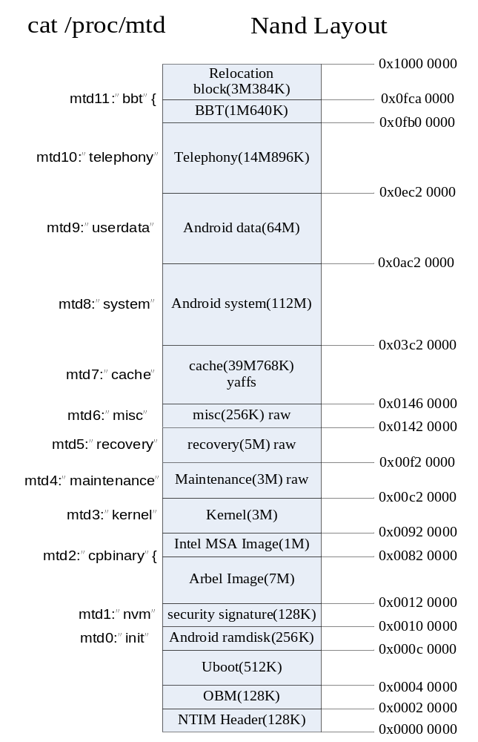

Debug Target board

ADB
ADB is a very basic tool for Android debugging. You can use ADB as default debugging tool for Android debugging.
$ adb device
$ adb shell
$ adb push src target

logcat
There has a tool embedded in Android called logcat which can log out useful information just like serial port.
- Usage: logcat [options] [filterspecs]
most important options include:
  - -f <filename> Log to file. Default to stdout
  - -v <format> Sets the log print format, where <format> is one of:
brief process tag thread raw time threadtime long
  - -b <buffer> request alternate ring buffer
('main' (default), 'radio', 'events‘)
filterspecs are a series of <tag>[:priority], where <tag> is a log component tag (or * for all) and priority is:
- V Verbose
- D Debug
- I Info
- W Warn
- E Error
- F Fatal
- S Silent (supress all output)
- Examples
  - logcat & (backgroud running)
  - logcat –b radio –f rild.log & (Output ril related log to the file rild.log)
  - logcat –v time –b radio > rild.log (Output ril related log with time tag to file rild.log )

(Type logcat –-help to find how to use it.)

GDB
- adb push $SRC/out/target/product/xxx/symbols/system/lib/libc.so /system/lib/libc.so
- adb push $SRC/prebuilt/android-arm/gdbserver/gdbserver /system/bin
- On board: gdbserver 192.168.1.101:5544 --attach $PID
gdbserver 192.168.1.101:5544 $APP
- On host: arm-eabi-gdb
set solib-search-path
$SRC/out/target/product/xxx/symbols/system/lib;
$SRC/out/target/product/xxx/symbols/system/bin
target remote 192.168.1.101:5544

Native Lib Debug

1. Check stack
*((int*) 0) = 1;
static void debuggerd_connect()
{
unsigned tid = gettid();
int s = socket_local_client("android:debuggerd",
ANDROID_SOCKET_NAMESPACE_ABSTRACT,
SOCK_STREAM);
if(s >= 0)
{
write(s, &tid, sizeof(unsigned));
close(s);
}
}
//Debuggerd server will output the stack info.

2. Using disassemble to trace crash
- cat /proc/$PID/maps
  - virual addr | perm | offset | dev NO | inode NO | path
  - ac000000-ac14a000 r-xp 00000000 1f:09 523 /system/lib/libxxx.so
  - ac14a000-ac14f000 rwxp 0014a000 1f:09 523 /system/lib/libxxx.so
  - r-read, w-write, x-execute, p-private, s-share
  - cat $SRC/build/core/prelink-linux-arm.map if prelinked
- cp out/target/product/saar/symbols/system/lib/libxxx.so ./
- arm-eabi-objdump –dSl libxxx.so > dump
  - d-disassemble, S-mix source, l-print line
- locate crash point by comparing log and dump

Java Related Debugging

1. Check service’s status
> service list
> dumpsys [service name]

2. Check Stack by signal sending
> kill -3 PID
> cat /data/anr/trace.txt ???

3. Check current Stack by adding code
new Exception(“print trace”).printStackTrace();

4. Trace method call stack ( the tool will produce a png file )
- android.os.Debug.startMethodTracing(“/data/test”);
- android.os.Debug.stopMethodTracing();
- $SRC/out/host/linux-x86/bin/traceview test.trace
- $SRC/out/host/linux-x86/bin/dmtracedump -g test.png test.trace

5. Hprof data file
a) Produce prof:
- kill -10 $PID
- Add code
  - android.os.Debug.dumpHprofData(“/data/tmp/input.hprof”);
b) Analyze:
- $ adb pull /xxx/yyy.hprof ./
- $ANDROID_SRC/out/host/linux-x86/bin/hprof-conv input.hprof output.hprof
- Using Eclipse MAT tool to view the hprof data file. http://www.eclipse.org/mat/downloads.php
Tips:
- Install MAT pluggin for eclipse. http://www.eclipse.org/mat/downloads.php
- Run adb install/uninstall for many times
- Open DDMS in SDK tools or Eclipse’s DDMS perspective(Window->open perspective)
- Select the system server process in left window, click “DUMP Hprof file” in above toolbar
- After dumping finishes, select “Component report”
- See section “Biggest Toplevel Dominator Classes”
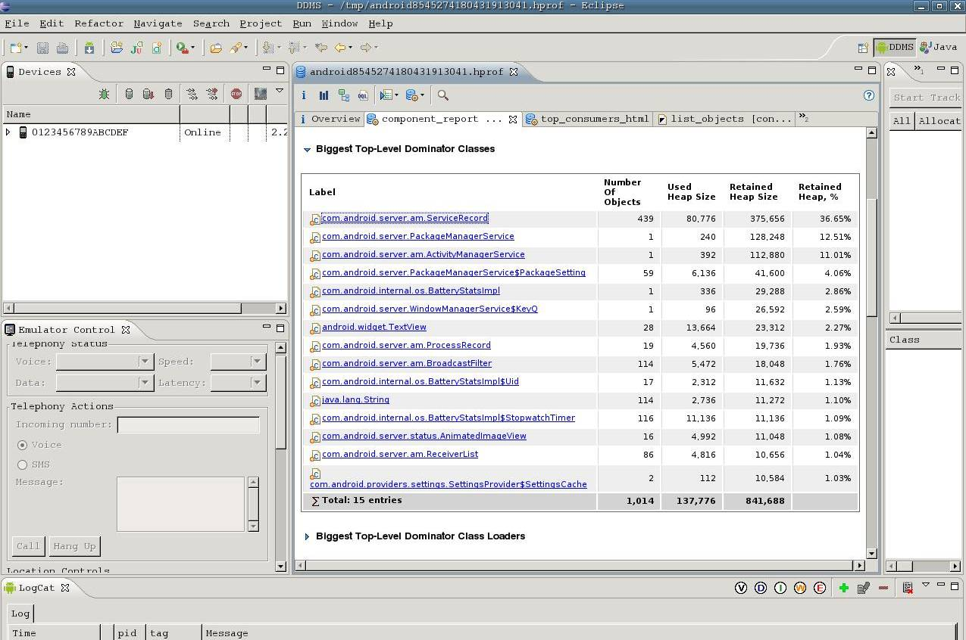
- click on “ServiceRecord”, open “List Objects” with incoming referece to see who refers to it.
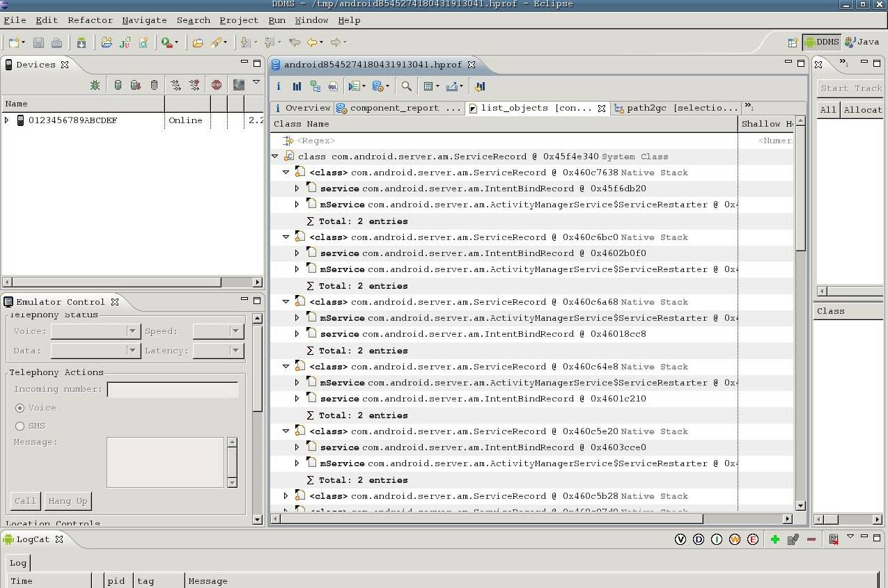
8 you can also see the the object’s path to GC
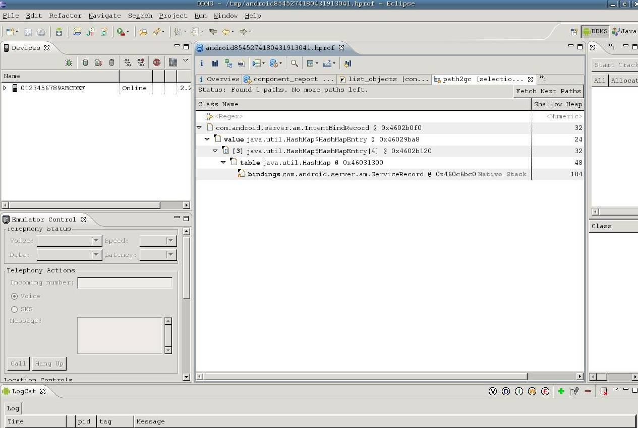

Symbol List
1. MSocket: based on Share memory and ACIPC, In user space, there will be MScoket wrapper which provides a standard MSocket interface [open/read/write/close] to user space components. MSocket wrapper hides the detail of Msocket driver operations, such as read, write, ioctl. The Port is just used to send/receive the data to/from Share memory. Each port corresponds to one service. There is a receiving queue for each port. There is flow control mechanism between port and peer port. ACIPC is used to notify new data, flow control and peer notify

